Club Log Exceptions

Jim Hargrave W5IFP

1.0 GENERAL

Logger32 provides the capability to automatically installes update a file of current exceptions from Club Log, Callsign and also installs the full list of Club Log prefixes.Prefix exceptions using data from Club Log.

2.0 SETUP AUTOMATIC UPDATE

To access and setup the automatic update, from the Logger32 Setup menu, select the Updates | Country database exceptions from Club Log menu items.

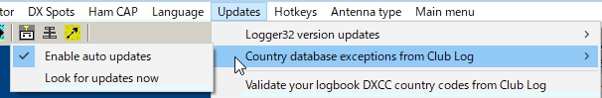

new CLE_1

If "Enable auto update" is checked then it will automatically trigger the update process daily. Summary page will automatically close at the end of the process.

Selecting the “Look for updates now” menu item will trigger the update process. Once the update completes you will see the Information in the "Update Country databases from Club Log" dialog.
If "Enable auto uodate" is unchecked then it is recommended to run "Look for updates now" once a week.

Note: If you select the “Enable auto updates” menu item the Exception list will automatically be updated daily. If this option is selected the summary page will automatically close at the end of the process.

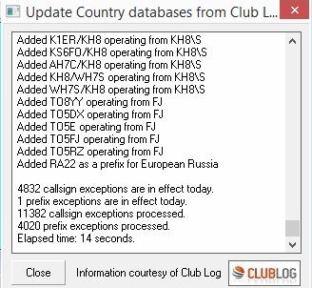

CLE_2

3.0 FULL PREFIX SYNCHRONIZATION

The menu option Full Prefix Synchronization installs the current exceptions from Club Log, and also installs the full list of Club Log prefixes. The daily exceptions will not run until the next update is available from Club Log.

Note: If you use Club Log exceptions to maintain your databases, you are encouraged to do an initial full prefix synchronization. Then once a month, or so, repeat the process. It takes less than a minute.

Here's the rationale: The Club Log exceptions are exceptions to the rule. But what is the rule? Take the case of 3G0ZC. The Club Log exception is NOT necessary because Club Log already has 3G0Z as a prefix for Juan Fernandez. Logger32 did not have 3G0Z as a prefix for Juan Fernandez, so 3G0ZC was not recognized correctly. The corrective action was to add 3C0Z as a prefix for Juan Fernandez to make the Club Log and Logger32 rules for this prefix the same. The full synchronization simply sets the rules in Logger32 to match the rules in Club Log.

3.0 4.0 VALIDATE DXCC COUNTRY CODES FROM CLUB LOG

This option synchronizes the logbook DXCC assignments to match the Club Log database. The user can opt to run this automatically or manual. In the Automatic mode (default) the changes will automatically modify your logbook DXCC assignment to match the Club Log database.

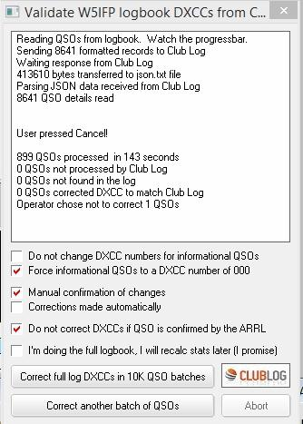

CLE_3

If the “Manual confirmation of changes” is selected, the user is presented an option to accept the Club Log assignment or reject it, leaving the QSO with the Logger32 assigned DXCC. This suggested change will appear anytime there is a QSO where the QSO DXCC does not match the Clublog DXCC assignment based on PFX and Callsign exceptions.

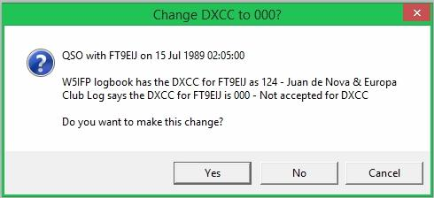

CLE_4

